**Experiment:- I-V Characteristics graph for different values of Ns & Np**

1. Ns=27, Np=1.

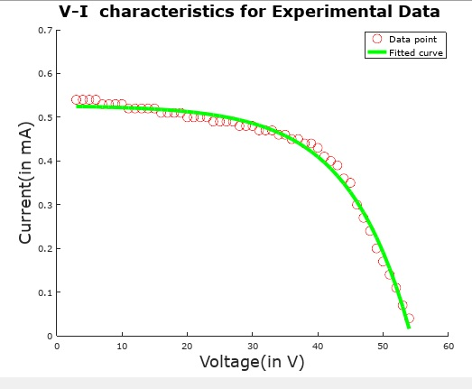

Fig.1.1:- Values for Fitted curve: Ns= 170 Np= 2.39

Iph= 0.21967 Irs= 7.3328e-004

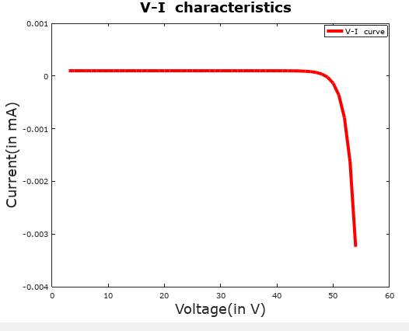

Fig.1.2:-Using value:- Ns=27, Np=1, Iph=10^(-4), Irs=10^(-18)

1. Ns=25 ,Np=3.

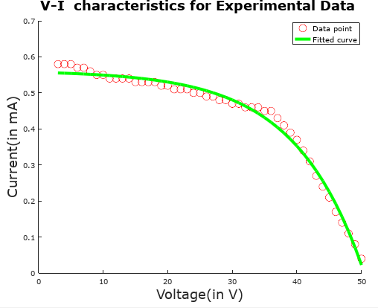

Fig.2.1:- Values for Fitted curve: NS= 188, Np= 0.63

Iph= 0.87248, Irs= 0.0074161

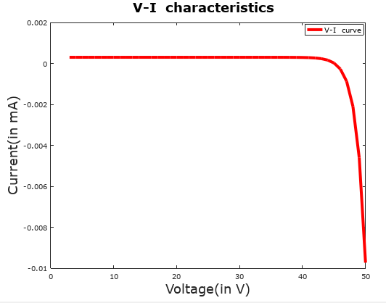

Fig.2.2:-Using value:- Ns=25, Np=3, Iph=10^(-4), Irs=10^(-18)

1. Ns=24 Np=4.

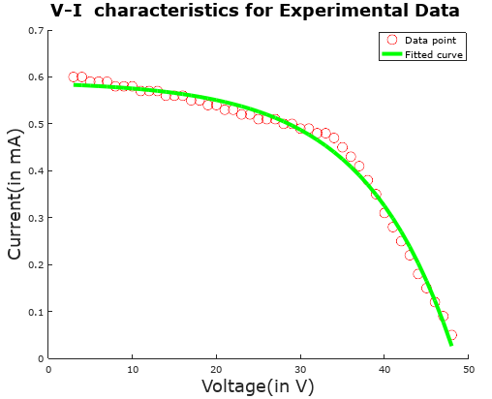

Fig.3.1:- Values for Fitted curve: NS= 190, Np= 1.879

Iph= 0.31256, Irs= 0.0033058

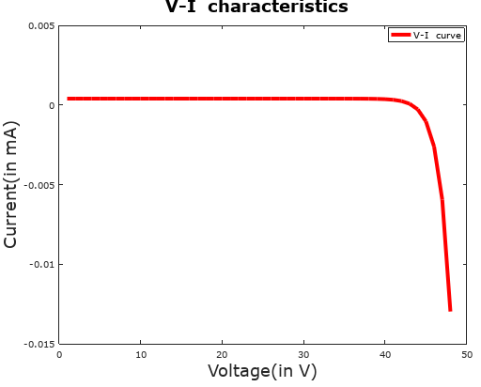

Fig.3.2:-Using value:- Ns=24, Np=4, Iph=10^(-4), Irs=10^(-18)

1. Ns=21 Np=7.

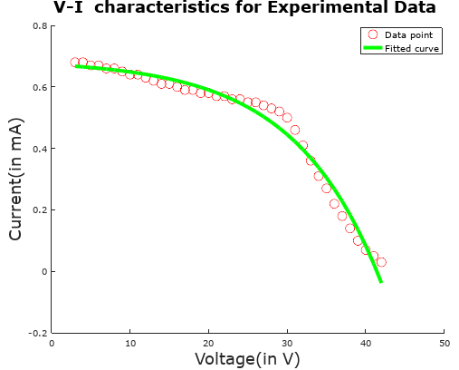

Fig.4.1:- Values for Fitted curve: NS= 195.89, Np= 0.729

Iph= 0.92190, Irs= 0.021563

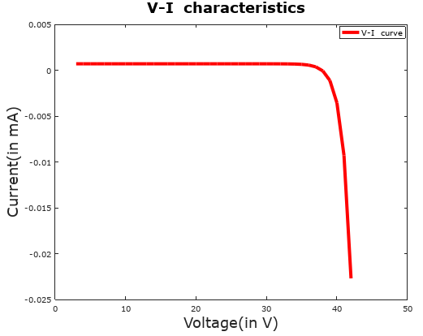

Fig.4.2:-Using value:- Ns=21, Np=7, Iph=10^(-4), Irs=10^(-18)

1. NS=18 Np=10.

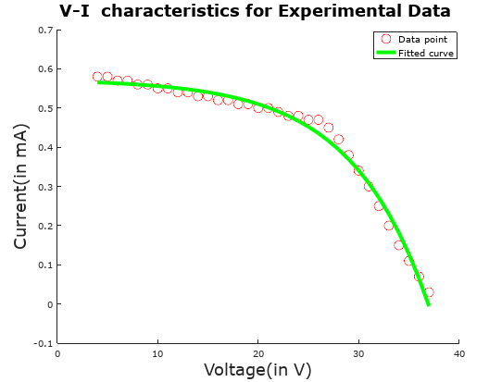

Fig.5.1:- Values for Fitted curve NS= 136.96, Np= 1.11

Iph= 0.5080, Irs= 0.0041375

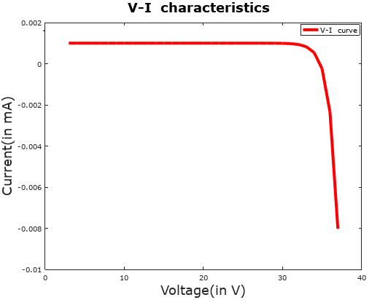

Fig.5.2:-Using value:- Ns=18, Np=10, Iph=10^(-4), Irs=10^(-19)

1. Ns=16 Np=12.

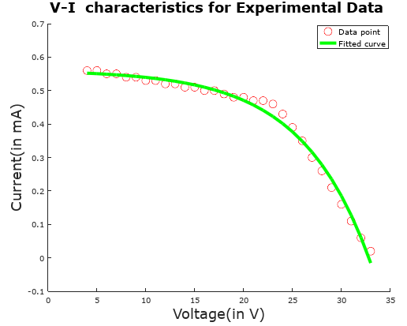

Fig.6.1:- Values for Fitted curve: NS= 125.34, Np= 1.987

Iph= 0.2797, Irs= 0.0026238

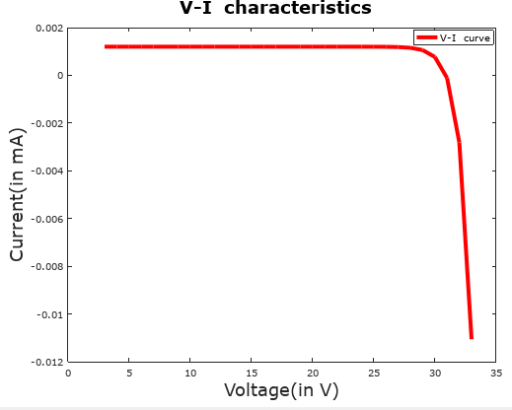

Fig.6.2:-Using value:- Ns=16, Np=12, Iph=10^(-4), Irs=10^(-19)

1. Ns=14 ,Np=14.

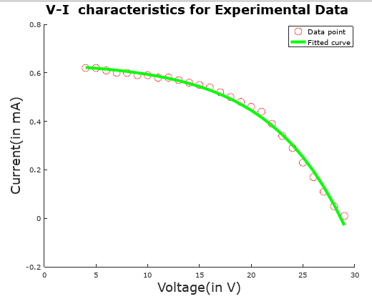

Fig.7.1:- Values for Fitted curve: NS= 132.47, Np= 5.64

Iph= 0.11193, Irs= 0.0023856

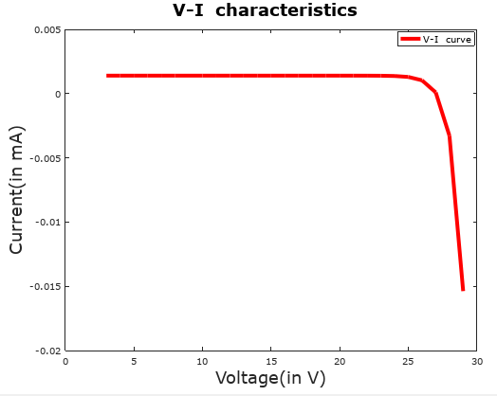

Fig.7.2:-Using value:- Ns=14, Np=14, Iph=10^(-4), Irs=10^(-19)

1. Ns= 11, Np=17.

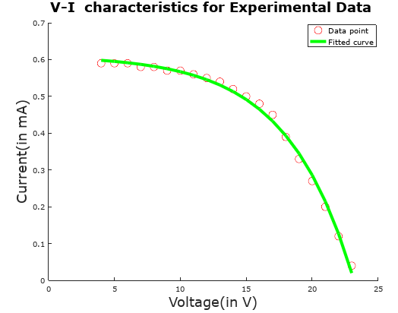

Fig.8.1:- Values for Fitted curve: NS= 89.54, Np= 4

Iph= 0.14918, Irs= 0.0014786

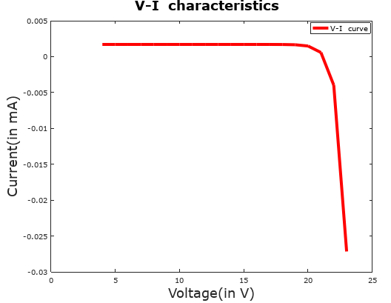

Fig.8.2:-Using value:- Ns=11, Np=17, Iph=10^(-4), Irs=10^(-19)

1. Ns=9, Np=19.

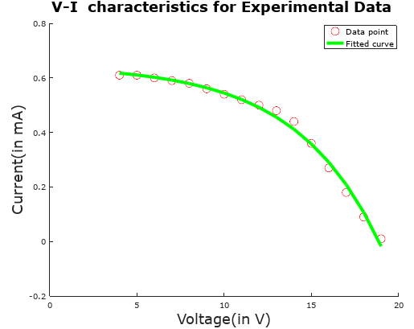

Fig.9.1:- Values for Fitted curve: NS= 85.95, Np= 0.084

Iph= 7.4965, Irs= 0.15100

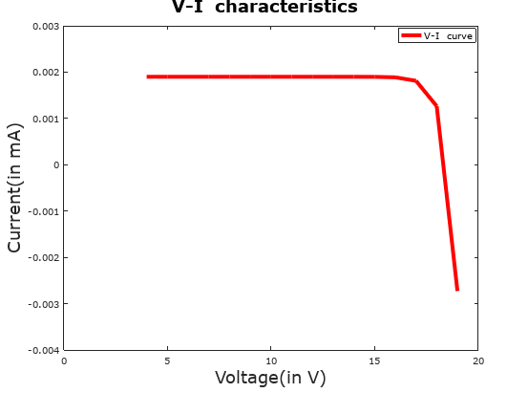

Fig.9.2:-Using value:- Ns=9, Np=19, Iph=10^(-4), Irs=10^(-20)

1. Ns=20 , Np=8.

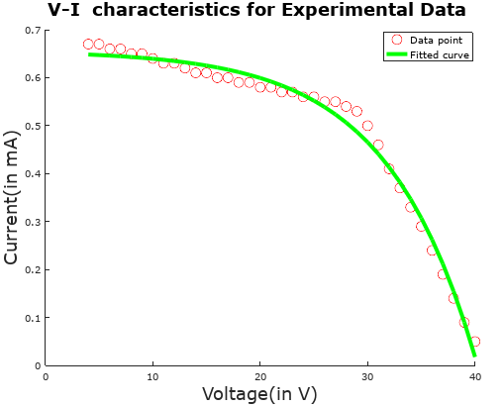

Fig.10.1:- Values for Fitted curve: NS= 148, Np= 0.17

Iph= 3.6228, Irs= 0.028401

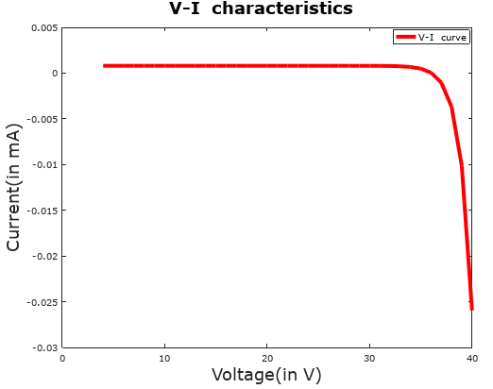

Fig.10.2:-Using value:- Ns=20, Np=8, Iph=10^(-4), Irs=10^(-18)

1. Ns=6, Np=22.

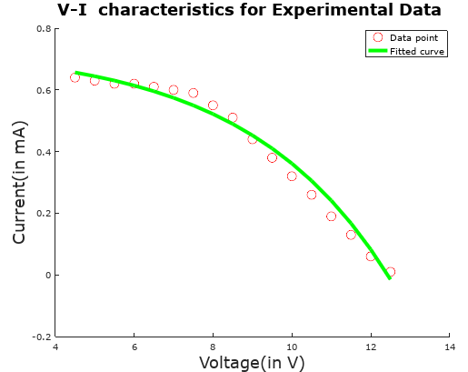

Fig.11.1:- Values for Fitted curve: NS= 64.680, Np=4.699

Iph= 0.15225, Irs= 0.0050727

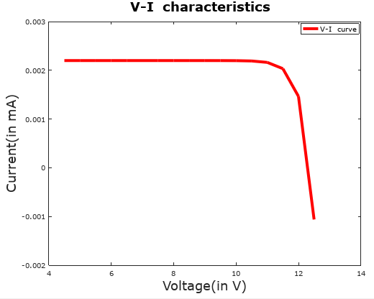

Fig.11.2:-Using value:- Ns=6, Np=22, Iph=10^(-4), Irs=10^(-20)

1. Ns=3 , Np=25.

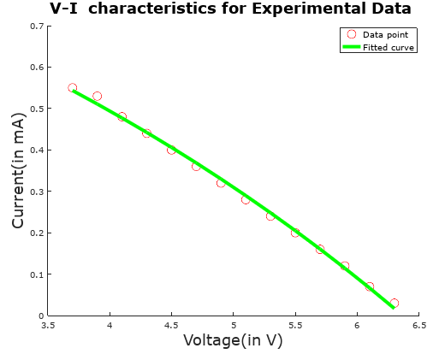

Fig.12.1:- Values for Fitted curve: NS= 102.95, Np=23.67

Iph= 0.041523, Irs= 0.020548

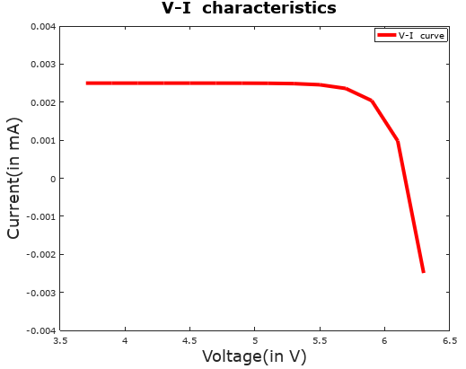

Fig.12.2:-Using value:- Ns=3, Np=25, Iph=10^(-4), Irs=10^(-20)